2016 Annual REport

Contents

Letter from the mayor 1

Introduction from the Chief Technology Officer 2

About Seattle IT 3

Creation of Seattle IT 3

Organizational Structure 4

Shared Service Divisions 4

Governance 5

VALUES 5

Revenue and Expenses 6

Strategic Priorities 8

Priority #1: Successfully complete key City-wide projects in flight 8

Priority #2: IT structure and governance 8

Priority #3: Security and Privacy 9

Priority #4: Data analytics 9

Priority #5: Technology and policy analysis 10

HIGHLIGHTS 11

IT Consolidation 11

Service Desk Integration 11

New customer information system (NCIS) 11

Next Generation Data Center (NGDC) 12

SEATTLE.GOV Redesign 12

Open Data Program 12

CIVIC TECHNOLOGY Program 13

digital equity 14

Technology Matching Fund award recipients 14

Wi-fi at Seattle Community Centers 15

AWARDS 16

Seattle Channel Wins Two Regional Emmy Awards 16

13 NATOA AWARDS 16

SEATTLE NAMED NUMBER FOUR DIGITAL CITY IN THE NATION 16

CITY OF SEATTLE DIGITAL EQUITY MANAGER WINS PRESTIGIOUS DIGITAL INCLUSION AWARD 17

Acknowledgements 18

# Letter from the mayor

Dear community members,

Seattle is a leading technology center with a tech-savvy population that has high expectations from its City government. Through the efforts of our newly consolidated Information Technology department, we are working to enhance and expand how technology helps us serve residents, businesses, customers, and visitors in our growing city.

Cities are entering a stage of transformational change that will be shaped by technology. Seattle continues to experience rapid growth that is changing our patterns of living and how we get around the city. These changes require the City to make more effective use of limited space, increase walkability, facilitate transportation, and find ways to support residents across the income spectrum. By strategically using technology to address the City’s social and economic needs, we can produce an improved urban environment.

I look forward to supporting technology professionals in our city to achieve my vision of a safe, affordable, vibrant, interconnected, and innovative Seattle for all.

Sincerely,



Edward B. Murray  
Mayor, City of Seattle

# Introduction from the Chief Technology Officer

 Dear community members,

I am pleased to present the 2016 Seattle Information Technology Annual Report. This has been an exciting year for Seattle Information Technology. On April 6, 2016 Seattle IT was formed from 15 legacy IT teams across the City. It was the largest consolidation of City departments in 15 years growing our staff from 200 to over 650 employees.

The benefits of joining together are already evident through increased efficiencies in our delivery of important technology projects across the City. Some of Seattle IT’s major accomplishments in 2016 include: completing the build of and migration two our new East and West data centers, successfully launching the New Customer Information System (NCIS) for Seattle City Light and Seattle Public Utilities, and promulgating our Open Data Policy which declares the City “open by preference” and directs all City departments to make their data available to the public except when doing so may affect individual privacy.

Thank you, Mayor Murray, Council President Harrell, and CTAB Chair Hirotaka for the opportunity to present this report. And thank you to the more than 650 Seattle IT staff who put their valuable skills to work in mission-driven service to the Seattle community. Together we will deliver powerful technology solutions for the City and public we serve.

Sincerely,  


Michael Mattmiller  
Chief Technology Officer, City of Seattle  
Director, Seattle Information Technology Department

# About Seattle IT

|  |
| --- |
| **Seattle IT Results Framework**  **Vision** One City, connected by technology  **Mission (Purpose)** Powerful technology solutions for the City and public we serve  **Objectives**   * Connecting people to their government * Enabling an effective and productive workforce * Building a digitally equitable community   **Principles**   * We will operate together as “One IT” * We handle information in a manner that engenders trust, promotes transparency, and protects privacy * For multi-department needs, we will have centrally managed IT solutions. For department-specific needs, we will strive for the selection of common platforms and approaches * Like all City investments, our plans for IT solutions will be based on compelling business cases and measurable outcomes * Address short term needs and invest for long term success |

The City of Seattle employs more than 650 information technology staff who deliver powerful information solutions for the City and the public we serve.

As Seattle strives to become a safe, affordable, vibrant, innovative, and connected City, the need for effective technology solutions is critical. Seattle IT supports the pursuit of this goal by:

* **Connecting people with their government.** Seattle IT operates the external face of the city: seattle.gov, Seattle Channel, and a suite of mobile applications. With a rapidly growing population and fast-paced business climate, more people than ever need timely information and services from their City government. Seattle IT is committed to furthering our online presence and tools to meet the needs of an innovative and creative city.
* **Ensuring an effective and productive workforce.** The talented, professional staff of Seattle IT are passionate about enabling our colleagues to serve the people and businesses of Seattle. In a region with a thriving technology industry, these individuals choose to devote their time to serving others. We provide powerful technology solutions to employees, helping them provide excellent service and meet the public where they are.
* **Building a digitally equitable community.** Internet access is the infrastructure challenge of the early 21st century. The internet, and the access to the information and services it provides, is responsible for economic growth, job creation, education, and a better way of life. But the internet only creates value for people if everyone has choices for equal and affordable access, and the digital literacy to use that access effectively.

## Creation of Seattle IT

In May 2015, Mayor Murray announced that City of Seattle employees working in the Executive Branch who perform information technology related duties would be consolidated into a new department, Seattle Information Technology Department to achieve the following:

* Create capacity to deliver on the most important technology projects in the City within current levels of staffing;
* Establish consistent standards and priorities for IT investments;
* Make IT a strategic business partner, enabling the delivery of IT solutions for a safe, affordable, vibrant and innovative city;
* Protect our resources from threats, especially related to security and privacy risks; and,
* Develop our workforce to evolve with technology, helping us to continually deliver technology solutions to meet the City’s objectives.

In November 2015, the City Council voted unanimously to create the new department and the consolidation started on April 6, 2016. The responsibilities and authorities of Seattle IT are defined in [Seattle Municipal Code (SMC) Chapter 3.23](https://www2.municode.com/library/wa/seattle/codes/municipal_code?nodeId=TIT3AD_SUBTITLE_IIDEOF_CH3.23SEINTEDE).

## Organizational Structure

To support Seattle IT goals, the organization was structured into two components: shared services and department teams.

**Shared services** includes our service teams such as strategy and planning or engineering and operations. These are overseen by directors reporting to the Chief Technology Officer and are structured in a manner modeled on the Information Technology Infrastructure Library (ITIL) plan-build-run model for delivering IT services, but modified to fit an organization of the City’s size and complexity. Having one delivery team in the City for a particular IT service allows for investment and service maturity that could not otherwise be afforded by a single department. Similarly, pooling resources will allow for more efficient usage and will create capacity to invest in other services not currently available, such as architectural planning.

**Department teams** are led by a Seattle IT department IT director. Initially, each department team will include most of the IT employees transferring to Seattle IT. As the shared service teams are formed over time, the department teams will have dedicated project management and business analyst resources to help envision and deliver strategic technology solutions in close coordination with department staff. The department IT directors will be responsible for the delivery of technology services to their department, and will work closely with department leadership teams. The IT directors will report to the Deputy CTO, with department directors playing a leading role in evaluating their performance.

Departments will work with these IT directors on the services they need to support their businesses. New processes and service strategies will be introduced gradually, and with customer input. This deliberate approach honors the close relationships with department leadership and existing business knowledge of IT staff, while providing a path to implement best practices, gain efficiencies, and invest in common platforms.

## Shared Service Divisions

Seattle IT’s organizational structure groups the department into six shared services, or functional divisions, each led by an executive director, plus eight department teams, each led by an IT director.

The six shared services, or functional divisions, are:

* **Applications.** Designs, develops, integrates, implements, and supports application solutions in accordance with citywide architecture and governance.
* **Business Office.** Provides the business services that enable the successful operation of the department. Provides cost and performance transparency to customers and ensures department accountability.
* **Digital Engagement.** Identifies and employs technology to connect the public to their government and ensures digital equity across Seattle.
* **Engineering and Operations.** Designs and implements, operates, and supports technology infrastructure solutions in accordance with citywide architecture and governance.
* **Security, Risk, and Compliance.** Manages the City’s information security, privacy, risk, and compliance programs by balancing the need to safeguard the City’s assets, infrastructure, and data with the City’s commitment to openness, transparency, equity, and innovation.
* **Strategy and Planning***.* Facilitates development of the City’s technology architecture and strategy, and manages the department’s portfolio of projects.

## 

## Governance

Two governance bodies advise Seattle IT directly, per SMC 03.23.030(M). The Mayor’s IT Subcabinet (MITS) establishes strategic IT priorities for the City and provides executive oversight of the department. The Business Steering Committee (BSC) monitors the performance of the department and helps review envisioned IT projects.

The Community Technology Advisory Board (CTAB) advises the Mayor and City Council of technology trends affecting the City and makes recommendations to Seattle IT, per SMC 03.23.060.

# VALUES

Prior to the department’s consolidation, IT leadership brought together representatives from each legacy department to form a Culture and Values team whose task was to come up with a set of values that would help create the desired culture for the new department. The Culture and Values team then worked with their respective divisions and derived the following values for Seattle IT.

* **Customer Focus:** Connect closely with internal partners and the community, providing exceptional customer service.
* **Accountability:** Serve the departments and people of the City with integrity, while honoring our commitments.
* **Transparency:** Conduct business openly by sharing information, valuing contributions, and understanding how our work impacts others.
* **Innovation:** Elevate the technology experience of our employees and customers, supporting the vision of the City by implementing smart, targeted solutions.
* **Collaboration:** Invest in each other with mutual respect, operating as one team to promote an efficient workplace.
* **Leadership**: Lead by example, creating a safe and trusting environment where we are empowered to do our best work.
* **Diversity:** Enable people with differing perspectives, backgrounds, identities, and abilities to reach their full potential.

# Revenue and Expenses

The 2016 Adopted Budget for Seattle IT prioritized the successful completion of critical initiatives and ensuring the City's information technology (IT) infrastructure and systems were safe, secure and compliant with regulatory standards. At the time the budget was adopted, Seattle IT was in the midst of several major initiatives: restructuring the way IT services are delivered across the City, implementing a privacy program, and ensuring the City's compliance with various regulatory standards.

The budget also sustained investments made in priority projects and initiatives including the City's public-facing performance measurement and tracking dashboard, replacement of the City's email archiving system, and the replacement of the current emergency alert and notification system. Finally, the adopted budget reflects the transition to the new Next Generation Data Center environment, completion of the Microsoft Office 365 migration and support for critical elements of the regional public safety 800Mhz radio system.

The unspent budget, or net income, reflected below will be carried forward to 2017 for the continuation of related projects.

|  |  |  |
| --- | --- | --- |
| **Revenue** |  |  |
| Non-General Fund | $76,151,097 | 64.49% |
| General Fund | $31,957,629 | 27.06% |
| Cable Franchise Subfund | $9,407,077 | 7.97% |
| Other | $568,153 | 0.48% |
| Total revenue | **$118,083,956** | **100%** |
|  |  |  |
| **Expenditures** |  |  |
| Personnel Costs | $72,118,064 | 65.26% |
| Other Expenses | $30,982,635 | 28.03% |
| Depreciation Expenses | $7,415,938 | 6.71% |
| Total Expenditures | **$110,516,637** | **100%** |
|  |  |  |
| **Net income\*** | *$7,567,319* |  |

*\* (includes funds collected in 2016 which are committed for expenditures in 2017)*

# Strategic Priorities

In February 2015, the Mayor’s IT Subcabinet (MITS) approved five strategic priorities to drive the City’s technology investments in delivery through 2016. Seattle IT led execution of projects and completed key activities aligned with each priority.

## Priority #1: Successfully complete key City-wide projects in flight

Teams originally comprised of IT staff from across departments are currently working on three large City-wide projects. The projects include the PCI compliance readiness, Next Generation Data Center (NGDC), and Office 365. Completion of these multi-year projects are critical to the development and delivery of future technology projects across departments.

In prioritizing the completion of these projects, MITS asks departments to commit the resources necessary to complete these projects as scheduled in 2015 and 2016. As the top IT priority in the City, completing these projects takes precedent over other projects.

### 2016 Status

Seattle IT successfully completed the three projects, attaining PCI DSS Level 1 compliance in July 2015; completing its migration to Office 365’s Exchange Online in February 2016 and SharePoint Online services in December 2016; and completing the buildout and migration to NGDC in September 2016.

In January 2016, the Mayor’s IT Subcabinet added a project to this priority, Summit Reimplementation Initiative (SRI), the replacement of the City’s PeopleSoft financial management system. This project is on track to go live in January 2018.

## Priority #2: IT structure and governance

Prior to 2016, IT services in the City were delivered by 15 largely decentralized teams with duplicative services offered in many departments. In 2014 the Mayor directed the CTO to identify opportunities to better coordinate the delivery of IT services and create additional capacity for technology projects across the City. The creation of MITS and establishing a new vision for IT governance was the first step in this process. In prioritizing structure and governance, MITS asks the CTO to envision a structure for IT service delivery in the City that centralizes common services and defines a model for department-specific needs and to enhance IT governance by empowering the Technology Board, the City’s existing governance body, to make decisions that facilitate implementation of MITS’s direction. The new organizational and governance structures must align decision making and improve accountability. These structures must also consider evolving resourcing and technology delivery models, such as cloud computing.

### 2016 Status

Working with key stakeholders, Mayor Murray and the CTO announced plans to create the new Seattle Information Technology Department (Seattle IT) on May 13, 2015, with all IT professionals in the Executive branch transferring to the new department. The City Council passed Ordinance #124920 on December 1, 2015, creating the new department effective April 6, 2016.

In addition to creating the new department, Seattle IT defined a governance structure with the Mayor’s IT Subcabinet providing strategic technology direction, the Business Steering Committee providing tactical engagement and performance review, and the Community Technoloy Advisory Board bringing the public’s perspective on how the City should consider technology. The Seattle IT Governance Advisor role was created to manage the department’s governance boards.

## Priority #3: Security and Privacy

The City’s IT infrastructure and services do not meet a level of security necessary to protect us from modern threats. The City lacks policies, standards, and procedures that drive the consistent selection and deployment of technology in a secure manner. While security investment and maturity ranges between departments, the City’s overall security posture is set by its weakest practices. A key objective of our security efforts is the protection of personal and other sensitive data. The City is in the midst of a Privacy Initiative through which it will make new commitments to the public for how personal information will be handled, used, and disposed of.

In prioritizing security, MITS asks the Technology Board to develop plans and begin taking steps to assess the City’s IT security risk, harden infrastructure and systems, increase staff awareness, and demonstrate compliance with IT regulatory requirements across the City’s IT environment.

### 2016 Status

Seattle IT has made significant progress standing up the City’s Privacy Program, which was created in response to guidance from a community advisory group and research completed in partnership with the University of Washington. By the end of 2016, more than 98% of Seattle Police department employees and 92% of other City employees with access to personal information completed the City’s inaugural privacy training.

As part of the IT consolidation team integration process, in fall 2016 Seattle IT created the new Security, Risk, and Compliance division. The Mayor’s 2016 budget included several investments in technology security, including increased funding and additional positions. As of the end of 2016, plans are being developed on how to structure the newly formed team and deliver on its most critical tasks.

## Priority #4: Data analytics

As a leading technology city, we recognize innovative technology solutions present an opportunity for government to operate more efficiently and exceed the public’s expectations. Such solutions often rely on predictive analytics, machine learning, or decision making techniques that rely on quality data from across multiple sources. While the City uses business intelligence tools today, often the data used in analyses is siloed within departments and not always stored in a manner that facilitates analysis. The City needs to develop a platform and service through which departments can stand up data analytics solutions that allow for better informed decision making and service to the public. At the same time, such services need to be implemented in a manner that protects the public’s privacy and facilitates data use in accordance with the City’s privacy commitments. SPD is leading the City in its consideration of data analytics platforms and is planning to issue an RFP to select such a platform in February.

MITS asks SPD to lead the City in its selection of a data analytics platform and implementation that can scale over time to meet the needs of the broader City.

### 2016 status

The primary purpose of the Data Analytics Platform (DAP) is to provide the Seattle Police Department (SPD) with enhanced reporting and analytical capabilities related to topics in a Settlement Agreement with the U.S. Department of Justice to demonstrate compliance to the Monitor/DOJ based on data collected from multiple non-integrated SPD systems.

In April 2016, the vendor (Accenture), the Seattle Police Department (SPD), and Seattle IT agreed to restructure the DAP project to address issues uncovered in the data and the environment and to better align the scope to SPD and Seattle IT goals.  The change resulted in a focus on Data Governance and creation of processes & procedures to improve data quality since it was important to the customer users that the reports are based on quality data, and creation of ad-hoc reports to validate results.

## Priority #5: Technology and policy analysis

In recent years, the City has had a mixed track record responding to technology trends and developments. Departments have individually responded with varying degrees of success to recent trends, such as the use of mobile computing to increase workforce productivity. Limited resources and other high-priority projects have affected the City’s ability to develop strategies for other trends like application rationalization, cloud computing, and enterprise content management.

MITS asks the Technology Board to analyze the current technology landscape to both identify gaps between the City’s use of technology and innovative organizations and also envision technologies the City should have in place within 3-5 years. This analysis should also consider gaps in policy that hinder adoption of technologies, put secure use of technology at risk, or lead to uses or implementations inconsistent with our Purpose and Principles.

### 2016 status

A significant amount of information gathering and analysis was done during 2016 to assess technology trends and developments as well as to identify gaps between the City’s current use of technology and what technologies needs to be in place within the next 3-5 years. Following up on the 2015 Technology Landscape report, Seattle IT completed a Technology Gap Analysis as well as the City Technology Benchmark Analysis, Digital Disruption System, and MITS Principle Technology Solutions reports. Seattle IT also analyzed policy barriers through its completion of a policy evaluation and policy remediation report. This groundwork has been critical in guiding the City’s Technology Strategic Agenda.

# HIGHLIGHTS

## IT Consolidation

On April 6, 2016, City of Seattle Information Technology operations consolidated from 15 city legacy departments into one new Seattle IT. The responsibilities and authorities of Seattle IT are defined in [Seattle Municipal Code (SMC) Chapter 3.23](https://www2.municode.com/library/wa/seattle/codes/municipal_code?nodeId=TIT3AD_SUBTITLE_IIDEOF_CH3.23SEINTEDE).

The newly consolidated department sought to achieve the following:

* Create capacity to deliver on the most important technology projects in the City within current levels of staffing;
* Establish consistent standards and priorities for IT investments;
* Make IT a strategic business partner, enabling the delivery of IT solutions for a safe, affordable, vibrant and innovative city;
* Protect our resources from threats, especially related to security and privacy risks; and,
* Develop our workforce to evolve with technology, helping us to continually deliver technology solutions to meet the City’s objectives.

## Service Desk Integration

Following the consolidation of staff into Seattle IT, the most public facing team in Seattle IT was also the first team to integrate. The Service Desk, comprised of former DoIT, Seattle Public Utlities (SPU), and City Light staff, has exceeded the service level agreement target with focusing resources on answering incoming calls especially during the high peak morning hours. Since the merge, the combined average speed of answer has been 11 seconds. None of the previously independent teams had achieved this level of performance in the year prior to consolidation.

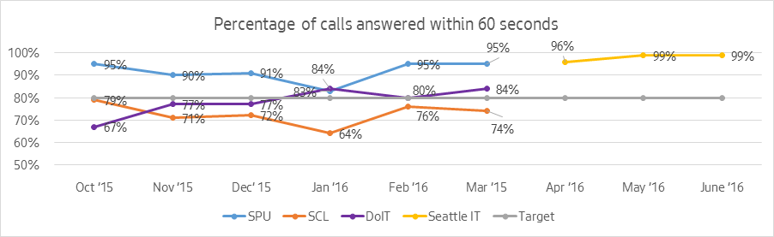

## New customer information system (NCIS)

The City replaced the 15 year-old billing system for Seattle City Light and Seattle Public Utilities in 2016, the culmination of four years of planning work, build-out and implementation. The new system improves customer service through easier access to utility accounts and increased protections of personal and private information. The system is used to collect nearly $2 billion in revenue and is used daily by more than 600 City staff.

## Next Generation Data Center (NGDC)

The Next Generation Data Center (NGDC) project was successfully completed in 2016. With one overarching goal: to create a new data system focusing on “redundancy and resiliency,” the project ran smoothly. The project has been successful in implementing a way to reliably back-up data more effectively than had been used before. Now, rather than keeping all the data in Downtown Seattle, City data is backed up in the Western Data Center (WDC) in Tukwila and the Eastern Data Center (EDC) near Spokane.

The relocation of the data has created a safety net for City data. Should a City-wide disaster happen, the data will be out of harm’s way and will be available for retrieval in more than one location. Since the NGDC was finished, it has become an integral player in improving organization and keeping the City’s data safe and protected.

## SEATTLE.GOV Redesign

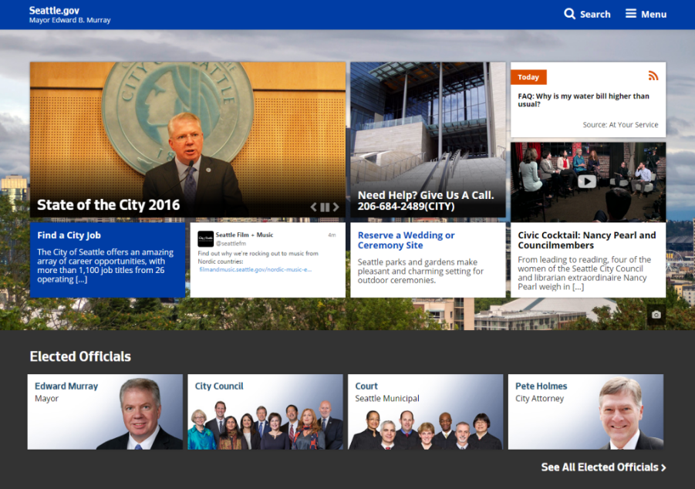In 2016, Seattle IT’s Web Team built and launched the City of Seattle’s redesigned website, www.seattle.gov, to better connect the public with their government. The new responsive website strives to be user-centric, organizing content primarily by City services instead of City departments.

The Web Team designed and built the new Seattle.gov over a three-year period, with all City pages updated in phased releases. The new site is a one-stop shop for the mayor, council, and all city departments.

## Data Analytics Platform (DAP) for Seattle Police Department

The Seattle Police Department (SPD) worked with Seattle IT and Accenture to build the Data Analytics Platform (DAP) which was rolled-out in 2016. DAP enables SPD to create reports and dashboards to better monitor, map, and predict crime throughout the City. The new platform better integrates data from a variety of sources and allows SPD leaders to utilize these reports and dashboards to make data-driven decsions based on analytics insights.

## Permit Systems Integration

The City launched its Permit Systems Integration (PSI) program, which seeks to create a coordinated and seamless experience across departments for permitting and licensing throughout the City, while meeting the internal needs of each department. The Seattle Department of Transportation (SDOT) and Seattle Department of Construction and Inspections (SDCI) became the first departments to migrate select permitting processes to the City’s new Accela platform. Additional permitting and regulatory processes across five departments will migrate to Accela between 2017 and 2019.

## open Data Policy

In February 2016, Mayor Murray issued Executive Order 2016-01, which declared Seattle is “open by preference,” and directed all City departments to make their data available to the public except when doing so may affect individual privacy. Seattle IT led the creation of an Open Data Policy that implements the requirements of the Mayor’s executive order by working in partnership with the Sunlight Foundation, University of Washington, and Bloomberg Philanthropies’ What Works Cities initiative.

The City published 146 open data sets in 2016. Seattle ranks 6th in the nation on the Code for America Open Data survey for the number and type of datasets we make available. The City is now focusing on increasing the availability of sought after datasets and automating the posting of data.

## CIVIC TECHNOLOGY

Seattle IT engaged with the local community on open data and a myriad of public technology projects throughout the year to further develop Seattle’s civic technology ecosystem. In March, Seattle IT partnered with AT&T Mobile for a “Parks and Recreation” themed hackathon that resulted in the development of several new apps, including [Seattle Trails](https://itunes.apple.com/us/app/seattle-trails/id1124560781?mt=8).

In April, we partnered with the U.S. Department of State, the University of Washington, Microsoft, and Vulcan to host a Seattle site for the global [Fishackathon](http://fishackathon.co/) on sustainable fishing.

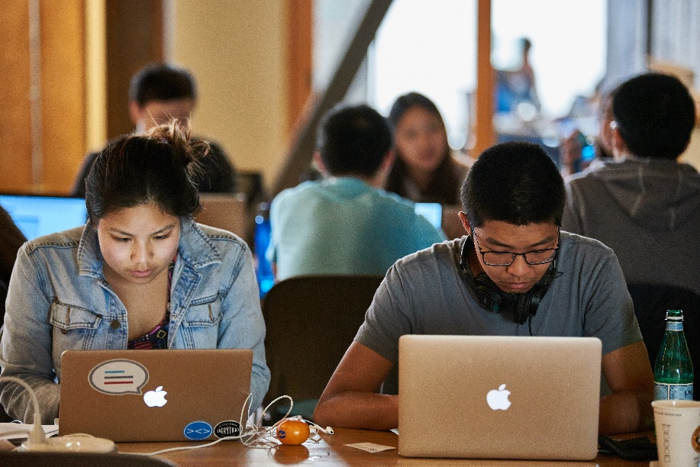In September, Seattle IT partnered with the U.S. Department of State, the Woodland Park Zoo, the University of Washington, Microsoft, and Vulcan to host a Seattle site for the [Zoohackathon](http://www.zoohackathon.com/) on ending wildlife trafficking.

Then in December, the City in partnership with Substantial and Open Seattle, participated in the Let It Snow! Community Design Workshop to envision innovative solutions for communicating with the public in the event of a winter weather emergency.

## digital equity

The City awarded ten community organizations a total of $320,000 in Technology Matching Funds.

The Technology Matching Fund projects help meet the city’s Digital Equity Initiative goals of increasing connectivity, digital skills training, and providing devices and technical support, through partnerships and community-driven solutions. The awards assisted more than 2,500 residents in historically underserved or underrepresented communities, including 580 immigrants and refugees, 1,240 seniors and 1,100 people with disabilities.

Seattle’s Community Technology Advisory Board selected the projects from 41 applicants though a rigorous application review process. Awardees contributed more than $470,000 in projected community matching resources. For more information and a map of Technology Matching Fund awardees, visit: <http://www.seattle.gov/tech/initiatives/digital-equity/technology-matching-fund/2016-awardees>

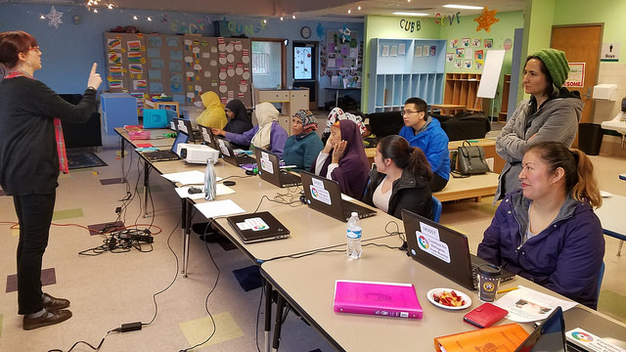

## Wi-Fi Expansion at Seattle Community Centers

Seattle IT upgraded Wi-Fi service at 26 Seattle Parks and Recreation Community Centers, helping thousands of new users get online. The service improvements were made possible by a grant from Google, which identified the need for improved internet access through the creation of the Digital Equity Action Plan. The City has seen Wi-Fii usage more than double in the past year thanks to the service improvements.

The upgrade project also enhanced capacity for digital literacy programming by replacing computers in community centers. Installation of the expanded service was led by Seattle IT, the Associated Recreation Council, and Seattle Parks and Recreation. Internet service at the community centers is donated by Comcast and Wave Broadband.

# AWARDS

## Regional Emmys

In 2016, the Seattle Channel received 17 Emmy nominations and won two Emmys for:

*CityStream: the Georgetown Steam Plant*, a story about the Georgetown PowerPlant Museum, won in the historic/cultural segment category.

*An American Hero: Shiro Kashino,* about a Wold War II veteran who grew up in Seattle’s Central District. The feature draws from the graphic novel *Fighting for America: Nisei Soldiers*, written by Lawrence Matsuda and illustrated by Matt Sasaki.

Seattle Channel is the City’s television station that reflects, informs and inspires the community it serves. Seattle Channel presents programs on cable television – channel 21 on Comcast (321 HD) and Wave (721 HD) – and via the Internet at seattlechannel.org to help residents connect with their city.

## NATOA Excellence in Government Programming

The Seattle Channel was named the best municipal television station in the nation when it received the prestigious Excellence in Government Programming award from the National Association of Telecommunications Officers and Advisors (NATOA.) Additionally, the station won 13 government programming awards, including five first-place wins for programming as well as a first-place award for its use of social media.

## Digital Cities Survey

In November 2016 the City of Seattle was named the fourth most digital large city (population above 500,000) by GovTech Magazine. Among the reasons cited for Seattle’s placement was the IT consolidation, launch of a [mobile-responsive website](http://www.seattle.gov/), a customer relationship management system to improve communications with residents, and a data analytics platform for the police department. Efforts to work with the city’s tech community include the hiring of a [civic technology advocate](http://www.govtech.com/people/Seattles-Civic-Tech-Advocate-Promotes-Innovation-Engagement.html) to engage with those individuals, a Hack the Commute program that developed prototype apps to help solve transportation issues, and a partnership with Code for America on the development of a crisis intervention app to connect people in need with social services.

## Digital Equity Champion

The National Digital Inclusion Alliance (NDIA) named David Keyes, Digital Equity Manager for the City of Seattle, the first recipient of the Charles Benton Digital Equity Champion Award.

The award recognized leadership and dedication in advancing digital inclusion -- from promoting the ideal of accessible and affordable communications technology for all Americans to crafting programs and policies that make it a reality. In nearly 20 years of public service in Seattle, David Keyes has used data to document community needs and direct programs, been committed to racial and social justice, and built a movement over time by engaging local elected officials, businesses, education partners, and community organizations in solutions.

# Acknowledgements

**Mayor Edward B. Murray**

**Council President Bruce Harrell**  
Chair, Education, Equity, and Governance Committee

**Michael Mattmiller, Chief Technology Officer**  
Director, Seattle Information Technology Department

|  |  |
| --- | --- |
| **Seattle IT Executive Team**  **Will Schoentrup**, Deputy CTO **Patti DeFazio**, Director, Business Office **Tara Duckworth**, Director, Applications **Jim Loter**, Director, Digital Engagement **Ryan Meeks**, Director, Strategy & Planning **Robert William Norris**, Director, Engineering & Operations **Dena Solt**, Director, Security, Risk, and Compliance **Andre Nellams**, Senior Manager, Human Resources **Megan Coppersmith**, Public Information Advisor | **Community Technology Advisory Board** **Amy Hirotaka**, Chair **Jose Vasquez**, Vice Chair, Public Access member **Christopher Alejano**, At Large member **Mark DeLoura**, At Large member**Iga Fikayo Keme,** Get Engaged member**Heather Lewis**, At Large member **Carmen Rahm**, Education member**Joneil Sampana**, At Large member **Eliab Sisay**, Get Engaged member **Nourisha Wells**, At Large member  **Karia Wong**, At Large member |
| **Mayor’s IT Subcabinet**  **Deputy Mayor Kate Joncas**, Chair **Susan Coskey**, Director, Human Resources **Robert Feldstein**, Director, Office of Policy and Innovation **Ray Hoffman**, CEO, Seattle Public Utilities **Scott Kubly**, Director, Transportation **Ben Noble**, Director, City Budget Office **Chief Kathleen O’Toole**, Seattle Police Department **Fred Podesta**, Director, Finance and Administrative Services **Chief Harold Scoggins**, Seattle Fire Department **Nathan Torgelson**, Director, Construction and Inspections **Larry Weis**, General Manager and CEO, Seattle City Light |  |